St. Michael’s & All Angels’ Church, Cathays, Cardiff
LEGACY POLICY

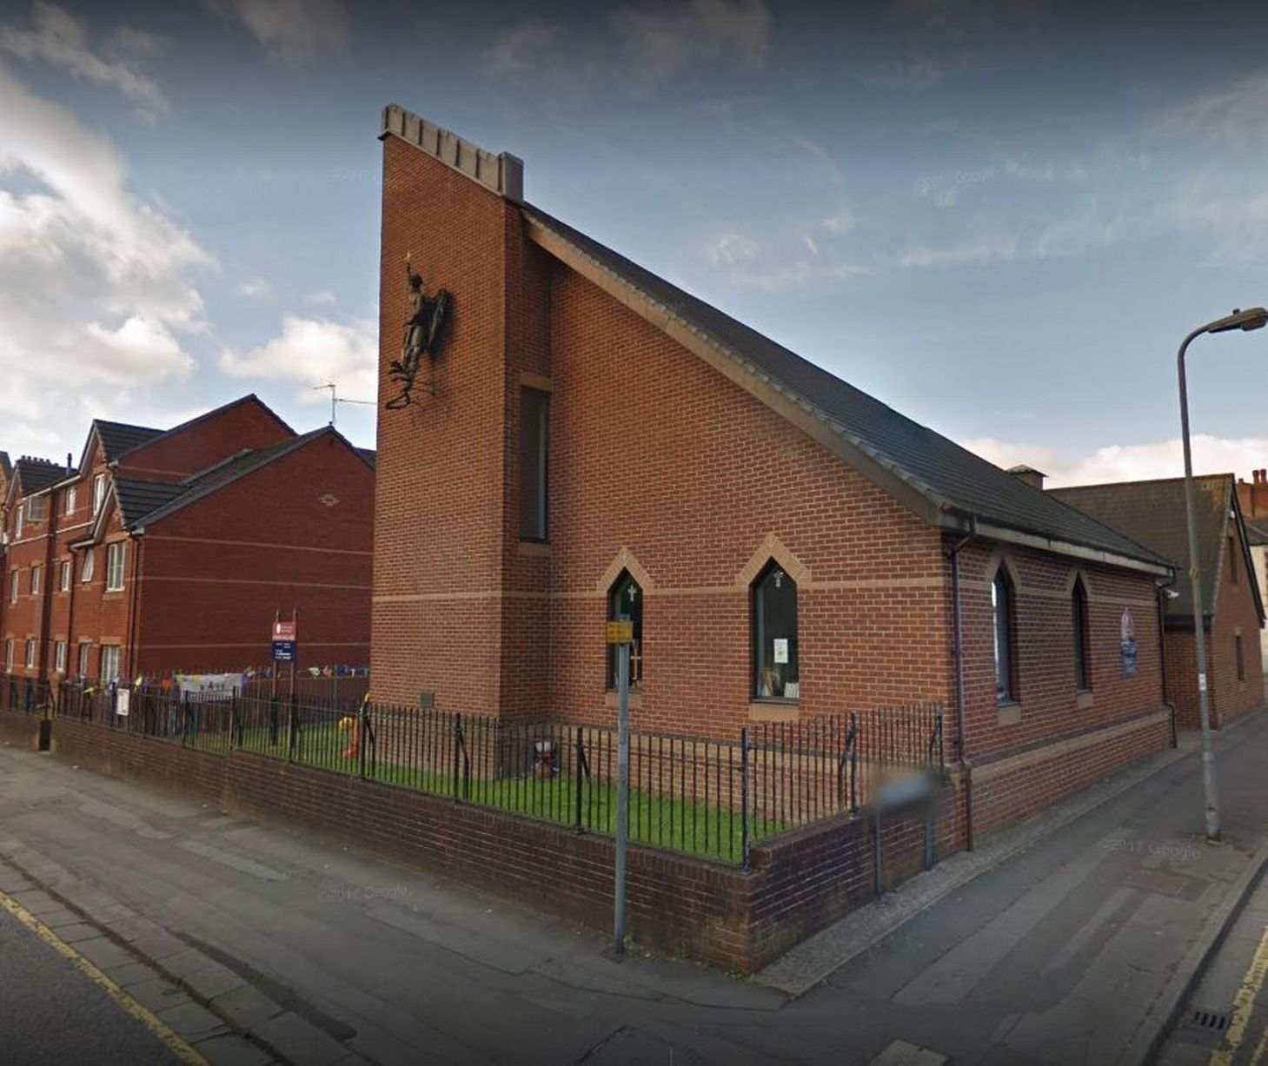
Here at St. Michael’s, we welcome all gifts in wills, however large or small, and we promise to use your gift to make a difference to our church. Our Legacy Policy is to use gifts to help fund development projects, whether buildings, equipment or staff; to maintain the fabric of the church; and to further the church’s mission.

Since needs change over the years, we would encourage you to leave a gift in your will for the general purposes of the church. You can specify if you would like your gift to go solely to St. Michael’s, or to be used for the wider benefit of the Ministry Area of Roath & Cathays, or to be divided between the two in a proportion you would decide. We will discuss possible uses of your gift with your executors when the time comes, bearing in mind your known areas of interest in St. Michael’s (e.g. music, buildings, children and youth, overseas mission or aid, flowers, hospitality) and the church’s priorities at the time.

You can be confident that your gift will be used to make a real difference to St. Michael’s church in the future.

We acknowledge gifts in whatever way the donor and/or his/her executors feel most appropriate. Equally, we can make sure that gifts remain anonymous if the donor prefers.

If you would like to talk to someone in confidence about the sorts of purposes your gift might fund, and how/if you would like your gift to be acknowledged, please contact Caroline – telephone 02920495699 or email carolinerebecca.downs@btinternet.com

If you would like to make a gift to our church in memoriam of a loved one, please come and discuss this with us too. It can be a wonderful and appropriate way to remember a loved one. Thank you for reading this!

Caroline & St. Michael’s Committee x

